Install mysql with driver. Keep password.

mysql --user=root --password=root // note two - -

Mysql>CREATE DATABASE dbf;

USE dbf;

**CREATE TABLE FIRSTTABLE (ID INT PRIMARY KEY, NAME VARCHAR(12));**

**INSERT INTO FIRSTTABLE VALUES (10,'TEN'),(20,'TWENTY'),(30,'THIRTY');**

**SELECT * FROM FIRSTTABLE;**

Exit;

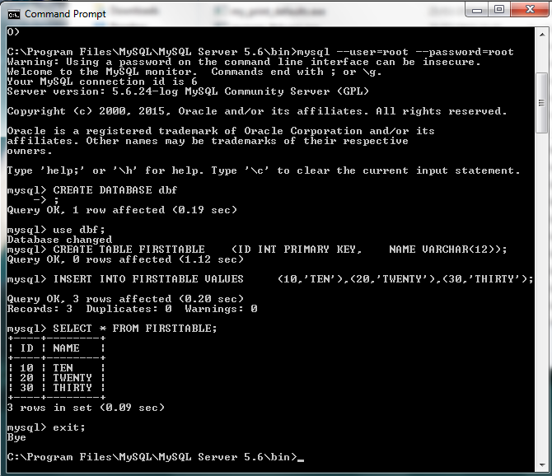

Now go to Eclipse. DATABASE , New connection. Make sure the driver set up correctly.

